Here are the pluggins and changes I have done in this weeks learning activity.


I activated a Contact form 7 plugging, that I placed at my contact form page. This so my visiters can contact med if they like to.

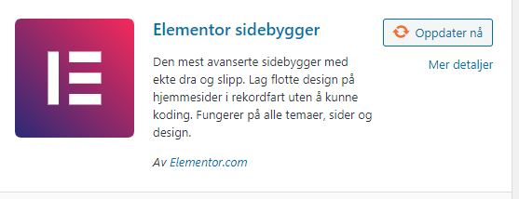
I activated a Elementor pagebuilder, that could make it easier for me to build up pages and posts in wordpress. I have not managed to test it so much yet.


I activated Google fonts plugging, so I can choose between many fonts.

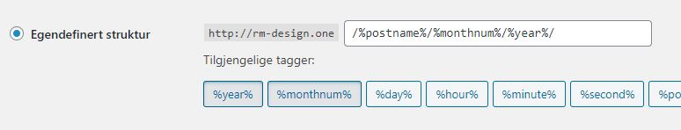
I changed my permalink for my site as you can see in the picture. This to get a better usability, aesthetic and compalitlity page.

